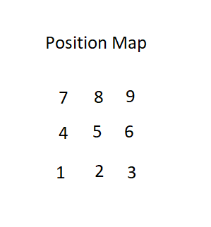
Motor Engage
E0 -engage x motor
E2 -engage y0 motor
E4 -engage y1 motor

Direction
E1 -x motor forward (high)
E3 -y0 motor up (high)
E5 -y1 motor up (high)

Switches
F0 -x motor = 0cm
F1 -x motor = 25cm
F2 -x motor = 50cm

F4 -y0 motor down
F5 -y0 motor up

F6 -y1 motor down
F7 -y1 motor up

How to get baseline exposure from auto_exposure

- Helpful commands when getting baseline
  - rqt
  - rosrun rqt_reconfigure rqt_reconfigure
  - rosrun image_view image_view image:=/camera/image_color

I have the baseline. Now what do I do?

How to make adjustments to the full motion sequence

A sequence failed in the middle. How do I rerun it from it’s last position?

Common Problems
- the lens cap is off you dummy
- the cord gets caught in motion and potentially ripped apart or crushed
- the lifts get stuck at the bottom position
- The “manual drive” will blow out the normal power if they are both on. Remove the relays before you power the “manual drive”

